Executive Summary: Exploratory Data Analysis of “Titanic Survival Drivers”
1. Overview and Purpose
This Exploratory Data Analysis (EDA) investigates the socio-demographic and economic factors influencing in the passenger survival rates aboard the Titanic. By evaluating passenger class, gender, age distribution, this analysis establishes how structural privilege and demographic prioritization determinate survival outcomes.
2. Data Description
The dataset contains 891 observations (rows) and 12 features (columns).
- Evaluated features: The featured contained in the data set are Passenger Id, Survived status, Passenger class, Name, Sex, Age', Sibling / Spouse, Parent/ Children, Ticket, Fare, Cabin and Embarked.
- Global Survival rate: Overall, 38.38% of the recorded passengers survived, while 61.62% diseased.
- Missing Values Analysis: A null-data analysis was performed to identify missing values in three columns: Cabin(687 missing values), Age (177 missing values not: handled via density distributions) and Embarked(2 missing values)
3. Bivariate & Multivariate Analysis (Hypotheses Testing)
3.1 Hypothesis #1: Passenger Class and Survival Rate
Survival rates demonstrate a strong inverse relationship with passenger class, decreasing gradually from upper to lower-level socio-economic class. (Figure 1)
- Class 1: Recorded the highest overall survival rate at 62.96%
- Class 2: Exhibited a moderate survival rate of 47.28%.
- Class 3: Showed the lowest survival rate at 24.23%.

Segregated analysis by gender reveals that socio-economic advantage interacted strongly with demographic prioritization (Figure 2):
- Class 1 & 2 Females: Recorded survival rates of 96.80% and 92.10%, respectively.
- Class 3 Females: Dropped significantly to a 50.00% survival rate.
- Males Across All Classes: Maintained consistently low survival rates, decreasing from 36.88% in Class 1 to 15.74% in Class 2 and 13.54% in Class 3.

  - Hypothesis #2: Gender Discrepancy and Survival Rate
Gender serves as the primary predictor of passenger survival:
- Females: Reached an overall survival rate of 74.20%.
- Males: Recorded an overall survival rate of 18.89%.
3.3 Correlation Analysis & Core Price Drivers
A Pearson correlation matrix validates these findings (Figure 4):
- Pclass vs. Survived (r = -0.34): Confirms that higher class status significantly increased survival probability.
- Fare vs. Survived (r = 0.26): Indicates higher ticket fares correlate with elevated survival rates due to class placement.
- Pclass vs. Age (r = -0.37): Shows older passengers predominantly occupied Class 1 accommodations, but did not necessarily belong to the higher group of survivors
- Age vs. Survived (r = -0.08$): Demonstrates a weak linear correlation, meaning that there is not non-linear relationship evaluated through age density distributions.

3.4 Hypothesis #3: Age Distribution and Survival Rate
Density curves (KDE) and count histograms reveal that survival rates are concentrated in specific group of ages (Figure 5 & 6)):
- Infants and Young Children (0–5 years): Displayed a peculiar survival peak, reflecting preference in the evacuation protocol.
- Young Adults (15–35 years): Represented the largest number of survivors, corresponding to the overall demographic peak of passengers aboard.
- Deceased Population: Concentrated primarily between 20 and 40 years of age.

5. Conclusion
This EDA confirms that Titanic survival rates were not random, instead, they were dominated by gender, socioeconomic status, and age:
- Gender Prioritization: Female passengers dominated the survival group across all classes.
- Class Advantage: Class 1 passengers have a survival advantage over Class 2 and Class 3, supported by strong negative correlation ($r = -0.34$) and positive fare correlation ($r = 0.26$).
- Non-Linear Age Impact: Age influenced survival selectively, benefiting infants (0–5 years) and young adults (15–35 years) while showing negligible linear correlation ($r = -0.08$) overall.
Appendix: Visualization and EDA Plots
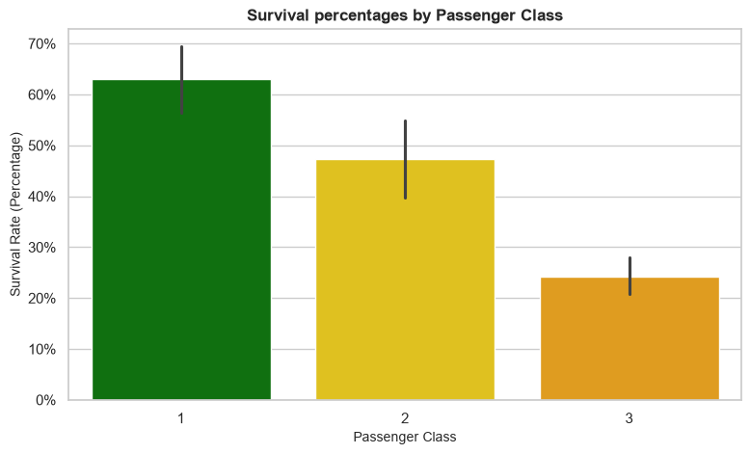
Figure 1 Bar graph of Survival rate by Passenger Class
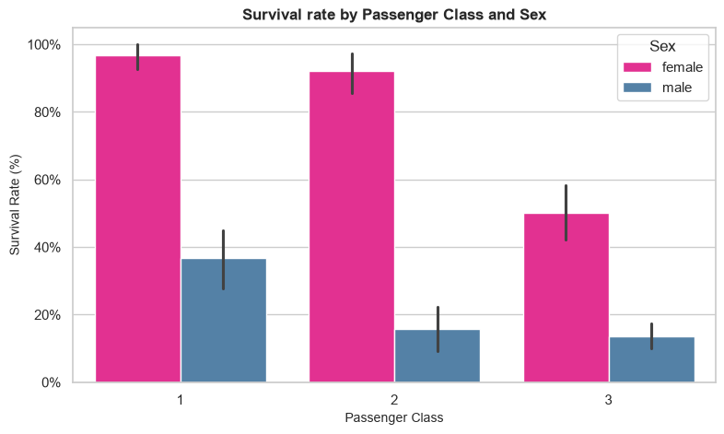
Figure 2 Bar graph of Survival rate by Passenger Class and Sex
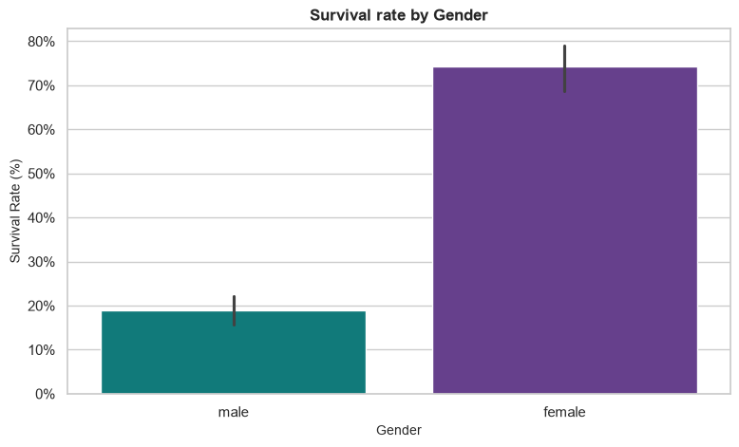
Figure 3 Bar plot of Survival rate by Sex
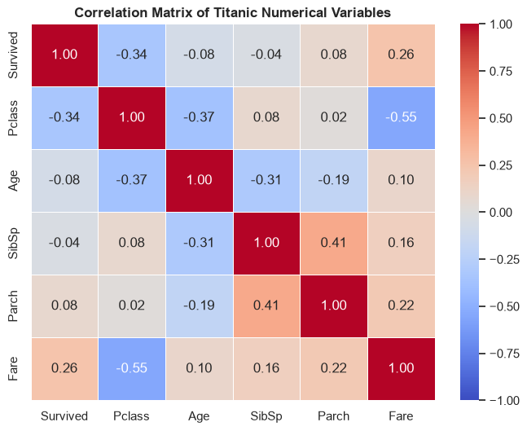
Figure 4 Correlation Matrix of Titanic Numerical Variables

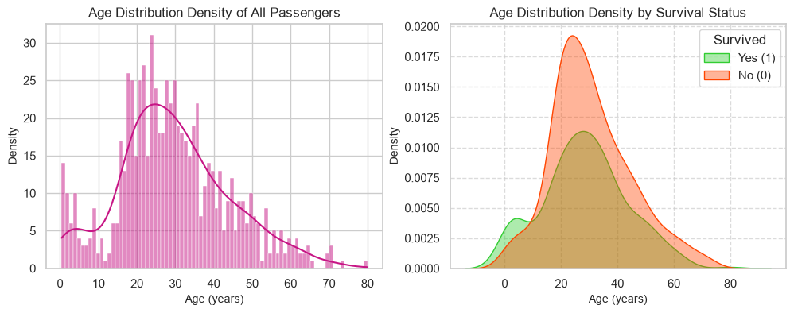
Figure 5 Histograms of Age Distribution Density by Survival Status

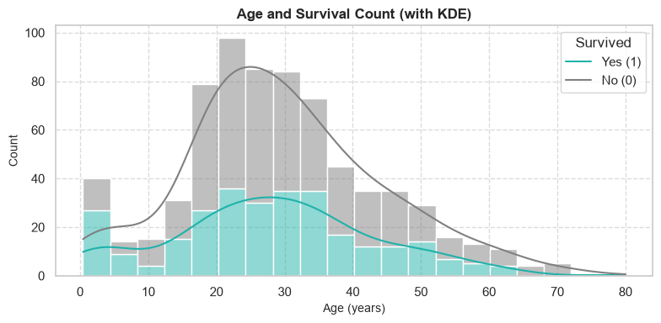
Figure 6 Histogram of Age and Survival Count (with KDE)

